Multi-Node Cluster Database with Cassandra on Ubuntu 14.04

Initial server setup

give the proper name for all servers that cassandra installed give that in /etc/hosts

#adduser demo
#gpasswd -a demo sudo

create automatic server ssh authentication using ssh-keygen and id_rsa.pub copying to autherized key in all hosts

Install Cassandra and Run a Single-Node Cluster

Cassandra requires that the Oracle Java SE Runtime Environment (JRE) be installed.
In all servers
#sudo add-apt-repository ppa:webupd8team/java
#sudo apt-get update
#sudo apt-get install oracle-java8-set-default
#java -version
java version "1.8.0_60"
Java(TM) SE Runtime Environment (build 1.8.0_60-b27)
Java HotSpot(TM) 64-Bit Server VM (build 25.60-b23, mixed mode)
Add the Apache repository of Cassandra to /etc/apt/sources.list.d/cassandra.sources.list, for example for version 3.6:

#echo "deb http://www.apache.org/dist/cassandra/debian 36x main" | sudo tee -a /etc/apt/sources.list.d/cassandra.sources.list

#curl https://www.apache.org/dist/cassandra/KEYS | sudo apt-key add -
#sudo apt-get update
#sudo apt-key adv --keyserver pool.sks-keyservers.net --recv-key A278B781FE4B2BDA
#sudo apt-get install cassandra

Troubleshooting and Starting Cassandra

#sudo service cassandra status
If it is not running, the following output will be displayed:
Output
* could not access pidfile for Cassandra
#sudo nano +60 /etc/init.d/cassandra
That line should read:
#/etc/init.d/cassandra
CMD_PATT="cassandra.+CassandraDaemon"
Change it to:
#/etc/init.d/cassandra

CMD_PATT="cassandra"
#sudo reboot
Or:
#sudo shutdown -r now
After logging back in, Cassandra should now be running. Verify:

#sudo service cassandra status
If you are successful, you will see:
Output
* Cassandra is running

Connecting to the Cluster

#sudo nodetool status
In the output, UN means it's Up and Normal:
Output
Datacenter: datacenter1
=======================
Status=Up/Down
|/ State=Normal/Leaving/Joining/Moving
-- Address Load Tokens Owns Host ID Rack
UN 127.0.0.1 142.02 KB 256 ? 2053956d-7461-41e6-8dd2-0af59436f736 rack1

Note: Non-system keyspaces don't have the same replication settings, effective ownership
#cqlsh
You will see it connect:
Output
Connected to Test Cluster at 127.0.0.1:9042.
[cqlsh 5.0.1 | Cassandra 2.2.2 | CQL spec 3.3.1 | Native protocol v4]
Use HELP for help.
cqlsh>
Type exit to quit:
cqlsh>exit

Deleting Default Data
#sudo service cassandra stop
When that's completed, delete the default dataset.
#sudo rm -rf /var/lib/cassandra/data/system/*

Configuring the Clustersudo

#nano /etc/cassandra/cassandra.yaml
. . .

cluster_name: 'CassandraDOCluster'

. . .

seed_provider:
- class_name: org.apache.cassandra.locator.SimpleSeedProvider
parameters:
- seeds: "your_server_ip,your_server_ip_2,...your_server_ip_n"(note i give the seed one ip ie master ip in all)

. . .

listen_address: your_server_ip

. . .

rpc_address: your_server_ip

. . .

endpoint_snitch: GossipingPropertyFileSnitch

At the bottom of the file, add in the auto_bootstrap directive by pasting in this line:

auto_bootstrap: false

First, restart the Cassandra daemon on each.
#sudo service cassandra start

#sudo nodetool status

if two system added in to the cluster then

Datacenter: datacenter1
=======================
Status=Up/Down
|/ State=Normal/Leaving/Joining/Moving
-- Address Load Tokens Owns Host ID Rack
UN 192.168.1.4 147.48 KB 256 ? f50799ee-8589-4eb8-a0c8-241cd254e424 rack1
UN 192.168.1.6 139.04 KB 256 ? 54b16af1-ad0a-4288-b34e-cacab39caeec rack1

Note: Non-system keyspaces don't have the same replication settings, effective ownership information is meaningless

some times its not get the ports are bloking 9042,7000 so we want to configure firewall using ip tables

#cqlsh your_server_ip 9042

Connected to My DO Cluster at 192.168.1.6:9042.
[cqlsh 5.0.1 | Cassandra 2.2.3 | CQL spec 3.3.1 | Native protocol v4]
Use HELP for help.
cqlsh>

cqlsh>CREATE KEYSPACE vvv
WITH REPLICATION = {'class' : 'SimpleStrategy', 'replication_factor': 2 };
note :here is describe the simple strategey with in a datacenter..we can add multiple datacenter to conncet using network topology startegy)
cqlsh>use vvv;
cqlsh vvv>CREATE TABLE crossfit_gyms_by_location (
country_code text,
state_province text,
city text,
gym_name text,
PRIMARY KEY (country_code, state_province, city, gym_name)
) WITH CLUSTERING ORDER BY (state_province DESC, city ASC, gym_name ASC);

cqlsh vvv>INSERT INTO crossfit_gyms_by_location (country_code, state_province, city, gym_name) VALUES ('USA', 'CA', 'San Francisco', 'San Francisco CrossFit');
INSERT INTO crossfit_gyms_by_location (country_code, state_province, city, gym_name) VALUES ('USA', 'CA', 'San Francisco', 'LaLanne Fitness CrossFit');
INSERT INTO crossfit_gyms_by_location (country_code, state_province, city, gym_name) VALUES ('USA', 'NY', 'New York', 'CrossFit NYC');
INSERT INTO crossfit_gyms_by_location (country_code, state_province, city, gym_name) VALUES ('USA', 'NY', 'New York', 'CrossFit Metropolis');
INSERT INTO crossfit_gyms_by_location (country_code, state_province, city, gym_name) VALUES ('USA', 'NV', 'Las Vegas', 'CrossFit Las Vegas');
INSERT INTO crossfit_gyms_by_location (country_code, state_province, city, gym_name) VALUES ('USA', 'NV', 'Las Vegas', 'Kaizen CrossFit');
INSERT INTO crossfit_gyms_by_location (country_code, state_province, city, gym_name) VALUES ('CAN', 'ON', 'Toronto', 'CrossFit Toronto');
INSERT INTO crossfit_gyms_by_location (country_code, state_province, city, gym_name) VALUES ('CAN', 'ON', 'Toronto', 'CrossFit Leslieville');
INSERT INTO crossfit_gyms_by_location (country_code, state_province, city, gym_name) VALUES ('CAN', 'BC', 'Vancouver', 'CrossFit Vancouver');

we can see all the key space by
cqlsh>SELECT * FROM system_schema.keyspaces;

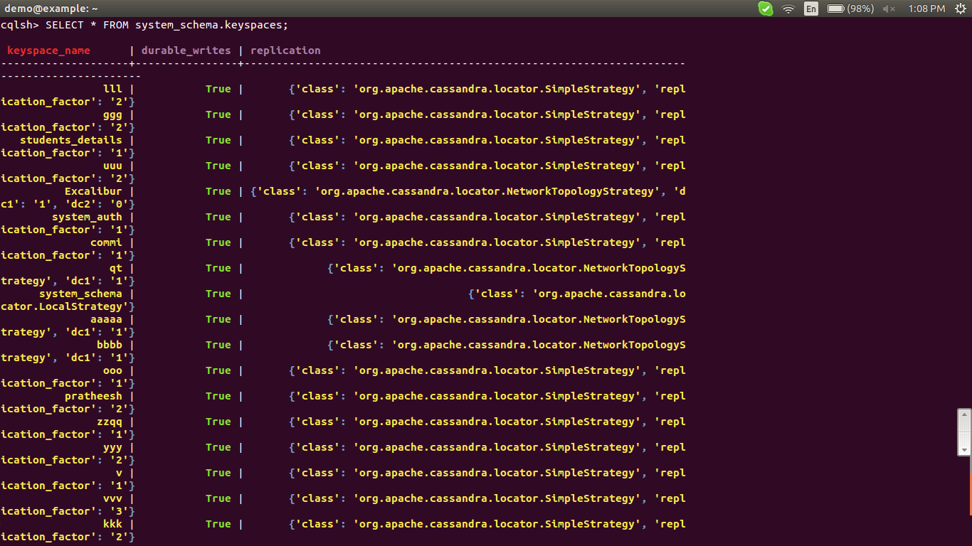
for seeing all table in the keyspace

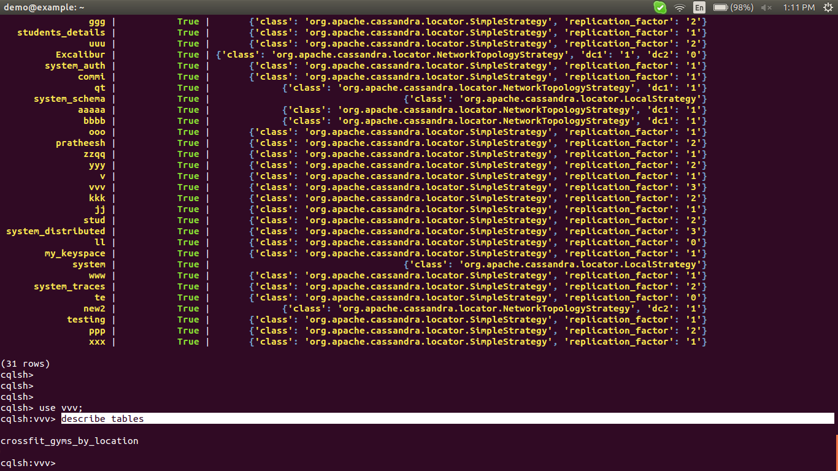

for seeing tables content in the keyspace
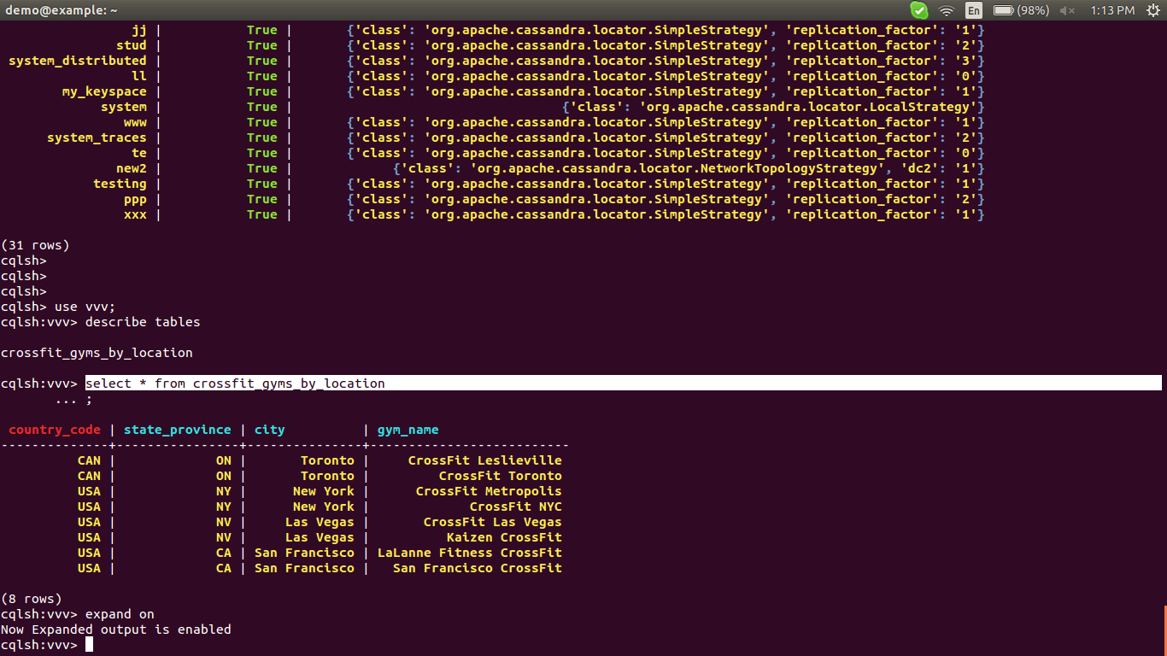
we can check the clustering is did or note by checking other server in the cluster
#cqlsh other server_ip 9042
with the same command check that key space and tables replicated or note

this links

https://www.digitalocean.com/community/tutorials/how-to-install-cassandra-and-run-a-single-node-cluster-on-ubuntu-14-04
https://www.digitalocean.com/community/tutorials/initial-server-setup-with-ubuntu-14-04
http://cassandra.apache.org/download/
https://www.digitalocean.com/community/tutorials/how-to-run-a-multi-node-cluster-database-with-cassandra-on-ubuntu-14-04

http://datascale.io/cassandra-partitioning-and-clustering-keys-explained/
https://blog.knoldus.com/2016/10/18/cassandra-data-modeling-primary-clustering-partition-compound-keys/
https://docs.datastax.com/en/cassandra/3.x/cassandra/configuration/configCassandra_yaml.html
https://docs.datastax.com/en/cassandra/2.1/cassandra/configuration/configGossipSettings_t.html

